Click here to enter text.

Click here to enter text.

Project Notes

Specimen Notes

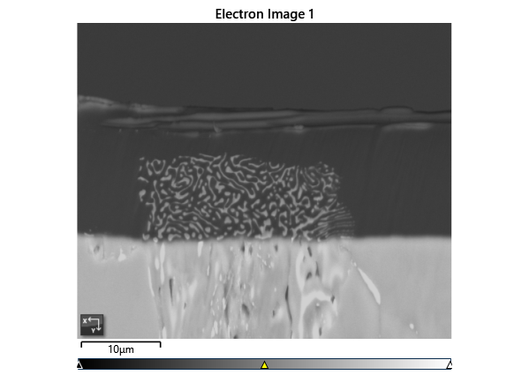

Settings

|  |  |
| --- | --- |
| Accelerating Voltage | 20.00 kV |
| Specimen Tilt (degrees) | 70.00 ° |
| Hit Rate | 88.23 % |
| Speed of Acquisition | 6.10 Hz |

Phases for Acquisition

|  |  |  |  |  |  |  |  |  |
| --- | --- | --- | --- | --- | --- | --- | --- | --- |
| Phase | a | b | c | Alpha | Beta | Gamma | Space Group | Database |
| Fe-FCC | 3.66 Å | 3.66 Å | 3.66 Å | 90.00 ° | 90.00 ° | 90.00 ° | 225 | OINA Phases |
| Fe-BCC | 2.87 Å | 2.87 Å | 2.87 Å | 90.00 ° | 90.00 ° | 90.00 ° | 229 | OINA Phases |
| Pb | 3.27 Å | 3.27 Å | 5.39 Å | 90.00 ° | 90.00 ° | 120.00 ° | 194 | ICSD |

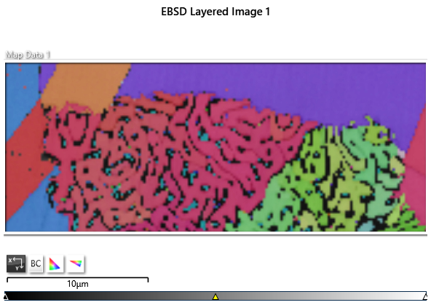

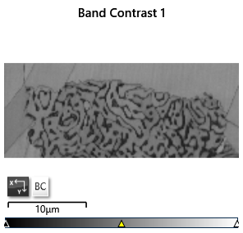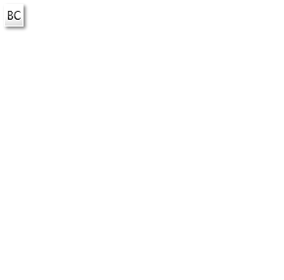

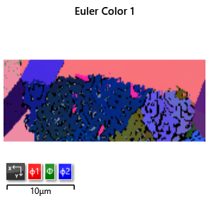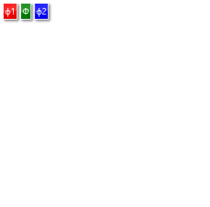

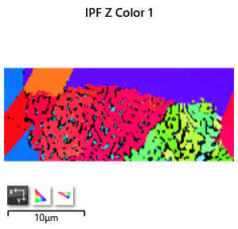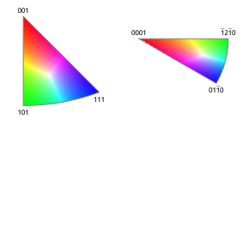

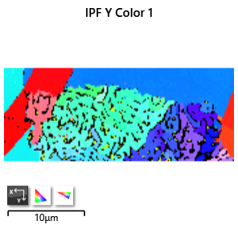

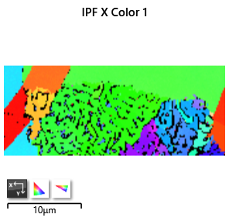

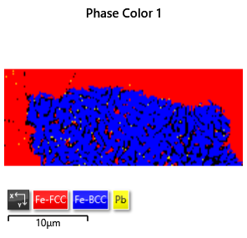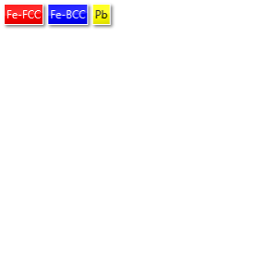

Phase Fraction

|  |  |  |  |  |  |  |  |  |  |  |
| --- | --- | --- | --- | --- | --- | --- | --- | --- | --- | --- |
| Phase Name | Phase Fraction (%) | Phase Count | Mean Band Contrast | Standard Deviation Band Contrast | Min Band Contrast | Max Band Contrast | Mean MAD | Standard Deviation MAD | Min MAD | Max MAD |
| Fe-FCC | 41.51 | 4869 | 130.31 | 18.49 | 34.00 | 149.00 | 0.78 | 0.19 | 0.17 | 1.89 |
| Fe-BCC | 46.10 | 5407 | 109.04 | 17.22 | 35.00 | 151.00 | 0.76 | 0.17 | 0.20 | 2.00 |
| Pb | 0.62 | 73 | 68.58 | 27.21 | 32.00 | 140.00 | 1.28 | 0.35 | 0.64 | 1.92 |
| Zero Solutions | 11.77 | 1381 | 50.30 | 16.25 | 0.00 | 125.00 |  |  |  |  |